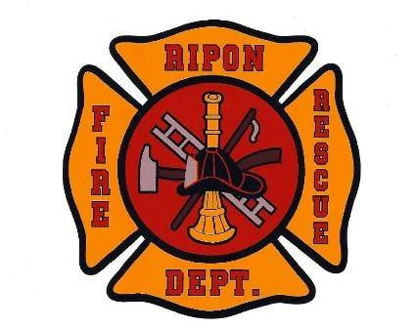

FOR IMMEDIATE RELEASE

The Ripon Area Fire District is pleased to announce the appointment of Frederick S. “Rick” James as the new Part-Time Fire Chief.

“We are thrilled to welcome Rick James as the next Chief of the Ripon Area Fire District,” said Ellen Sorensen, President of the RAFD Board of Directors. “Rick brings more than three decades of experience, strong leadership, and a genuine dedication to public service. His expertise and collaborative approach will be a positive addition to our department, helping strengthen our team and support our continued growth.”

James joins the Ripon Area Fire District with 32 years of experience in the fire service, including 30 years with the Appleton Fire Department. His extensive background encompasses fire suppression, emergency medical services, inspections, prevention, hazardous materials response, technical rescue, and training. At Appleton, he served in a wide range of roles, including fire inspector in the fire prevention division, company officer for 15 years, and Battalion Chief in the operations division for three years. His dedication and excellence were recognized when he was selected as Appleton’s Firefighter of the Year.

Beyond his municipal fire service experience, James worked for the State of Wisconsin at the Regional Emergency All Climate Training (REACT) Center as training coordinator and senior instructor. In these positions, he led strategic planning initiatives that transitioned the center from reliance on grant funding to becoming a self-sustaining, nationally recognized emergency response training provider. He oversaw a staff of up to 45 employees delivering instruction worldwide, developed operating budgets, and managed capital improvement projects.

James also brings significant experience from Wisconsin Task Force 1 (WI‑TF1), the state’s Urban Search and Rescue Task Force, where he served as one of three Task Force Leaders responsible for 150 members during training, exercises, and deployment. The role required advanced coordination across agencies, strong strategic planning abilities, and deep expertise in personnel management, budgeting, and grant oversight.

A graduate of Ripon College and long-time resident of the surrounding area, James maintains strong personal ties to the community. He began his fire service career with the Ripon Fire Department while attending Ripon College and currently serves with the Green Lake/Brooklyn Fire Department. He expressed his enthusiasm for this opportunity: “I am committed to working collaboratively with the Board of Directors, department personnel, elected officials, and community partners to ensure the Ripon Area Fire District continues to deliver reliable, responsive, and high-quality fire protection services.”

Sorensen added, “Rick started on July 8th, 2026 which marks an important step forward for the district. His leadership style, integrity, and deep knowledge of the fire service will help support the team and guide RAFD toward continued success.”

For further information, please contact:

Ripon Area Fire District
Ellen Sorensen, Board President
Phone: 920-960-3397
Email: esorensen@cityofripon.com

About the Ripon Area Fire District

The Ripon Area Fire District (RAFD) is dedicated to protecting lives, property, and the well-being of the communities we serve—the City of Ripon, the Town of Ripon, and 44% of the Town of Nepeuskun. Together, these municipalities make up a close-knit community of approximately 10,000 residents, with nearly 600,000 visitors each year.

The district proudly serves a vibrant and active area that includes Ripon College, a historic downtown, and a strong manufacturing base. The community is supported by an excellent public school district and offers a high quality of life with abundant parks, trails, and youth athletic programs.

