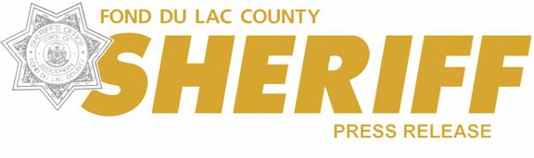

On Thursday, September 18, 2025, at approximately 12:37am, a Sergeant with the Fond du Lac County Sheriff’s office was on Interstate 41 south of Lost Arrow Road. The Sergeant observed a vehicle traveling Northbound at a high rate of speed, estimated to be in excess of 140mph. The Sergeant pulled out, activated emergency lights and siren, and attempted to catch up to the vehicle which was identified as a new model silver in color sedan.
Information was provided to nearby deputies and agencies. A Fond du Lac County Sheriff’s deputy, who was located at Interstate 41 northbound near Johnson Street, located the vehicle and attempted to stop it as the vehicle continued pass his location at a high rate of speed. The Fond du La County deputy with his emergency lights and siren activated, was able to positively identify the vehicle as being the vehicle in question.
The Fond du Lac County deputy pursued the vehicle with emergency lights and sirens activated. The vehicle in question failed to stop and continued traveling northbound on Interstate 41 increasing its speeds with minimal traffic on the roadways. The suspect vehicle passed other motorist on the shoulder as well as struck a construction barrel. Due to the active construction zone and safety concerns for the workers on the roadway near Lincoln Road on Interstate 41 the pursuit was terminated. The vehicle was last seen traveling northbound into Winnebago County on Interstate 41.
Vehicle information was later obtained through the investigation. The vehicle is described as being a 2024 Volkswagen Jetta, silver in color, with Georgia registration. At this time the vehicle has not yet been located, and the drivers’ information remains unknown. The case remains under investigation through the Fond du Lac County Sheriff’s Office.
The pursuit lasted approximately 15 miles. No emergency vehicles were damaged during the pursuit. No other vehicles or property were damaged during the pursuit.
The Fond du Lac County Sheriff’s Office was assisted by Wisconsin State Patrol and the Fond du Lac County Communications Center.

Sergeant Tyler Hoerig #158
Fond du Lac County Sheriff’s Office

