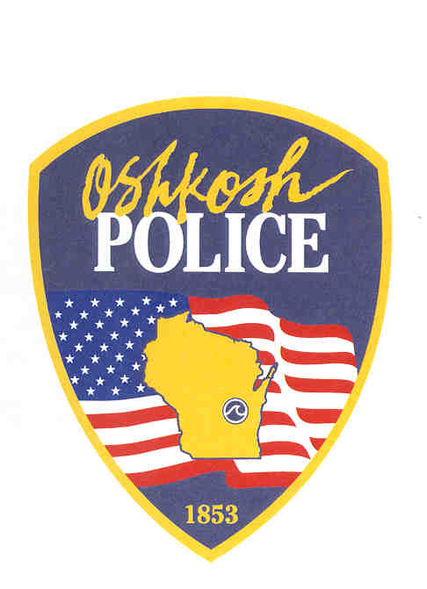

City of Oshkosh

Police Department

420 Jackson Street
Oshkosh, WI 54901
Tel: 920-236-5700
www.oshkoshpd.com

PROFESSIONALISM ● PRIDE ● INTEGRITY ● TEAMWORK

FOR IMMEDIATE RELEASE
OSHKOSH POLICE DEPARTMENT
________________________________________

Date: 08/02/2025
Time: 10:00 AM

Contact: Lt. Brett Robertson
Criminal Investigations Bureau
(920) 236-5735
Subject: Disturbance with A Weapon in the 1000 Block of Wisconsin St

OSHKOSH, WI (August 2, 2025): The Oshkosh Police Department investigated a disturbance with a weapon that occurred at a residence located in the 1000 Block of Wisconsin St in the City of Oshkosh.

On 08/02/2025 at approximately 2:53AM, Officers from the Oshkosh Police Department were dispatched to weapons call in the 1000 Block of Wisconsin Street. They received information that a 19-year-old male had been shot in the shoulder. The victim was transported to a local hospital with non-life-threatening injuries. He was treated and has since been released.

Detectives from the Oshkosh Police Department are actively working the investigation. This appears to be an isolated incident between two individuals. The suspect remains at large at this time.

If anyone has information regarding this incident, they are encouraged to contact the Oshkosh Police Department at 920-236-5700. If you have information about this incident, but wish to remain anonymous, please contact the Winnebago County Crime Stoppers at (920) 231-8477; or through the P3 App.

