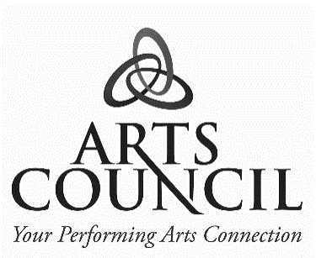 PRESS RELEASE

**For Immediate Release**

August 21, 2024

***Collin Raye Kicks Off The Arts Council’s 48th Season***

The Arts Council of South Wood County is thrilled to present the **Collin Raye Acoustic Trio** as the opening performance for its 48th season on Thursday, September 26, at 7:30 pm at the Performing Arts Center of Wisconsin Rapids. One of the true hit-makers of the 1990s, Collin Raye continues to crank out soulful, heartfelt material with the honesty and richness that is signature to his vocals alone. With 24 top-ten records, 16 #1 hits, and having been a 10-time male vocalist of the year nominee (5 CMA and 5 ACM), this truly electrifying performer of his era remains one of the great voices of our time.

Collin Raye is nothing if not passionate. His golden, pure voice and soulful delivery have set country standards in such searing ballads as “Love, Me,” “In This Life,” “Not That Different,” and “If I Were You.” Always an energizing showman, he has also blazed through such vivid rockers as “My Kind of Girl,” “That’s My Story,” “I Can Still Feel You,” and “I Want You Bad.”

Tickets are $59 for adults and $10 for students and are available online 24/7 at [www.SavorTheArts.com](http://www.SavorTheArts.com). For personal assistance, stop by 1040 8th Street South, Suite 101, Wisconsin Rapids, or call 715.424.2787, Monday through Thursday, 10:00 – 2:30. There are no ticketing fees; only sales tax is applied.

Season tickets are available if purchasing tickets to four or more of the season’s performances. Discounts of 5-15% will apply when purchased directly through The Arts Council. Also, if purchasing 10 or more tickets for a single performance in one transaction, a 15% savings will be applied—just call or stop in!

Sponsors of the performance include WSAW Channel 7, Haertel Monuments, FirstState Bank, and Radio Station WIRI 105.5 FM.

# # # # #

For additional information regarding this press release, please contact:

Sally Kissner | Executive Director

The Arts Council of South Wood County

715.424.2787

www.SavorTheArts.com